In this lesson we will fix things which was in our last lesson
and it happending in Teachers system but not in my system
Maybe it is happening because of his configuration in RigidBody
Lets see what mistake he is doing and what ew can learn from it
So when the teacher run the game then if the ball fall down then some glitch happens that all the platform in front of the ball will get out of there parent(who knows) and go in air
He never wanted this to happen so in this lesson teacher solve that

If we see then the platform has a rigid body attached to it but is kinematic is unchecked
If it is checked then no other physical or external force will be present on it
So if iskinematic propert is checked then no force can remove it from there position
So we go to platform and then check its isKinematic to true and then we apply this change in property to the prefabs made from it then we go to top of the inspector of platform then go to
as shown below where we go to override and then in submenu click on Apply alkl so that you can apply the changes in the platoform to the prefab made from it

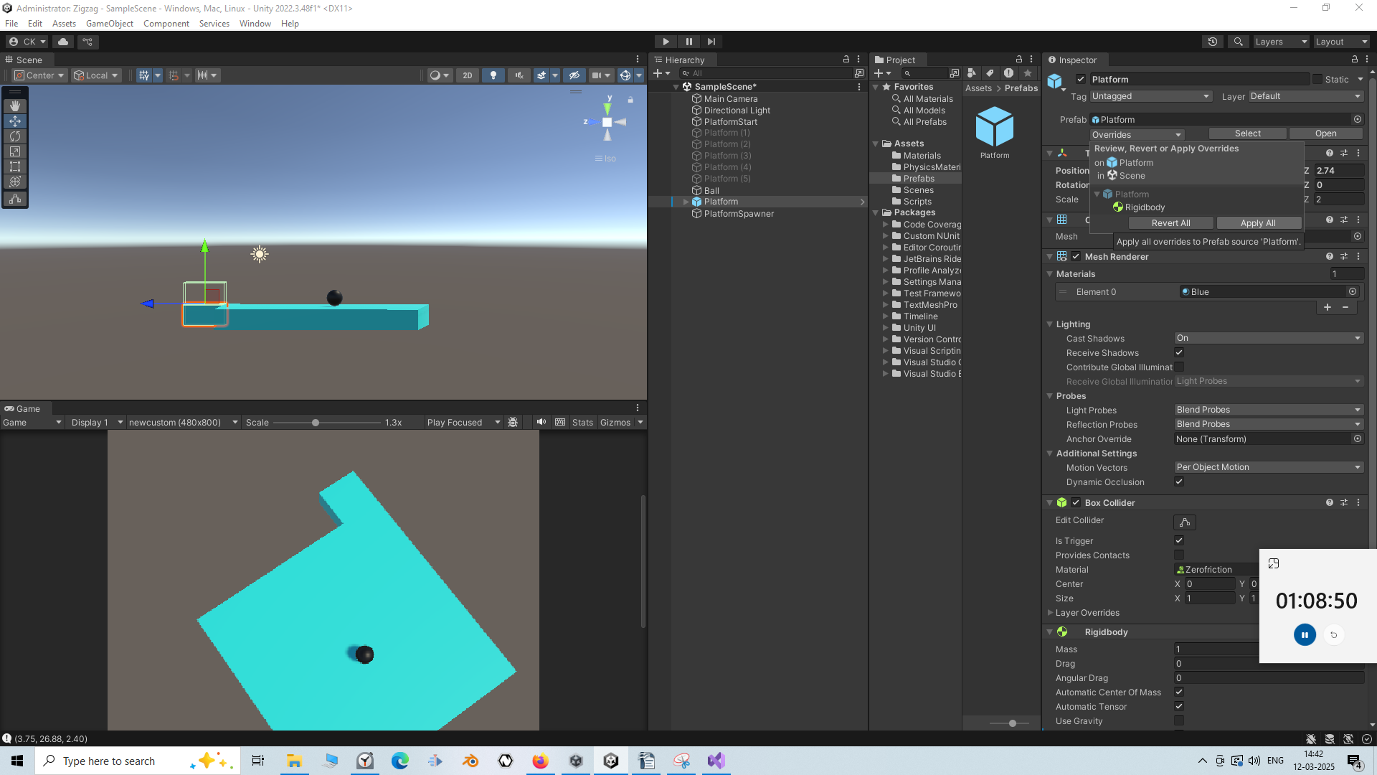

what is iskinematic in Unity

Unity mein isKinematic ek property hai jo Rigidbody component ke liye use hoti hai. Agar aap isKinematic = true set karte ho, to uska matlab hota hai:

isKinematic = true ka Matlab
- Object physics engine ke control mein nahi hota.
- Object ko forces, gravity, ya collisions affect nahi karte.
- Aapko manually object ka movement control karna padta hai (e.g., transform.position ya transform.Translate() ke through).
- Object triggers ko detect kar sakta hai, lekin physics collisions ka response nahi dega.

isKinematic = false ka Matlab
- Object physics engine ke control mein hota hai.
- Gravity, forces, aur collisions ka effect object pe hota hai.
- Aapko object ke movement ke liye Rigidbody ki properties jaise AddForce(), velocity ya angularVelocity ka use karna hota hai.

Kab Use Karein?
- isKinematic = true → Jab aapko object ka movement manually control karna ho (e.g., elevators, doors, scripted movements).
- isKinematic = false → Jab aapko physics-based movement chahiye (e.g., falling objects, rolling balls).

Example Code:
using UnityEngine;

public class KinematicExample : MonoBehaviour
{
public Rigidbody rb;

void Start()
{
rb = GetComponent<Rigidbody>();
rb.isKinematic = true; // Physics engine ka control hata diya
}

void Update()
{
// Manually move object
transform.Translate(Vector3.up * Time.deltaTime * 2);
}
}
Agar koi doubt ho to batao! ?
Now if you see now nothng goes in air after the the ball fall down but now the problem is that it does not fall down but we want i to fall down
Now we need something from the script So we need to go to TriggerChecker Script and then in fall Down what happens the we are setting the useGravity of the platorm to true

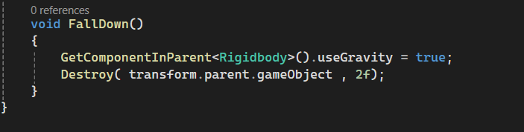
Now we will make the iskinematic false so that the plttform whihc the ball has passed falls down and the other platform ths ball has not passed will have iskinematic set to true so the force that occured because of a falling down platform will not be possible on the platoform the ball has not passed through
Now you will see that everything goes normal now
So teacher shows us what were the errors and after making the errors so tht you can learn from the mistakes and what can go wrong you can learn that
So in next lesson we will make some obstacles in the way so that we can make our score more point
We will learn how to make our score andwe are goint to learmn how to make our menus and our user interfaces
So we will see you in next lesson

